MEDI System Registration Instructions

1. MEDI System Home Page
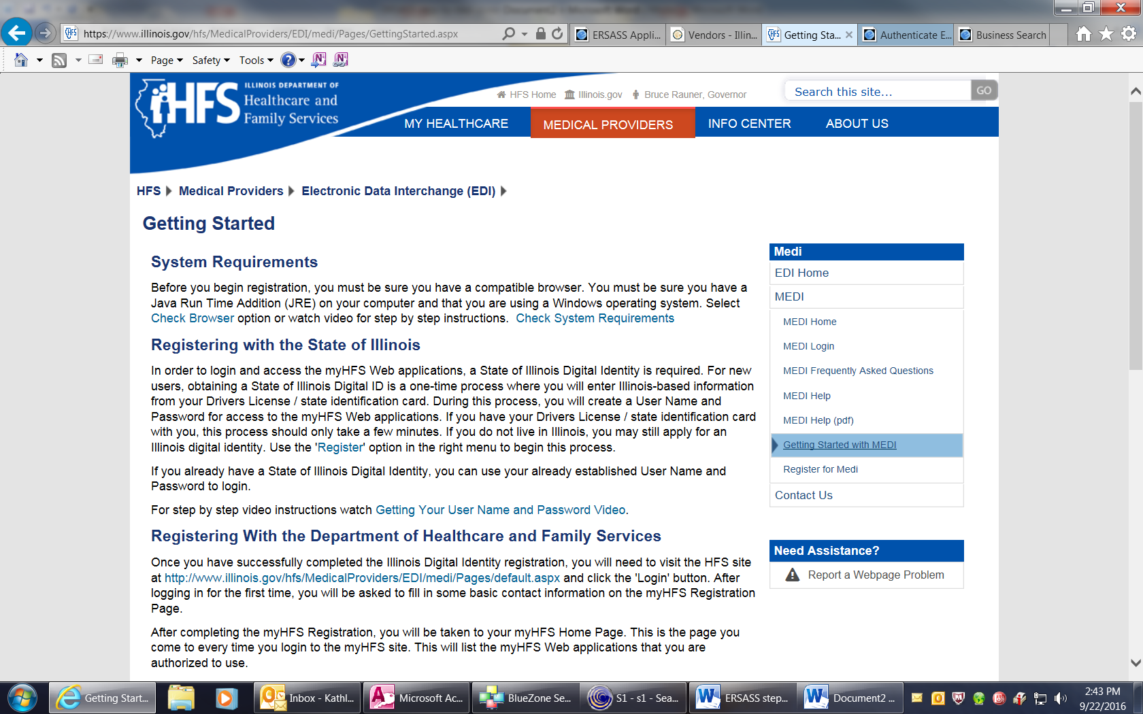
- Go to the MEDI website: www.myhfs.illinois.gov
- Select “Register for MEDI.” A brief Java check is done and then you will be redirected to the “Digital Subscriber Agreement.”

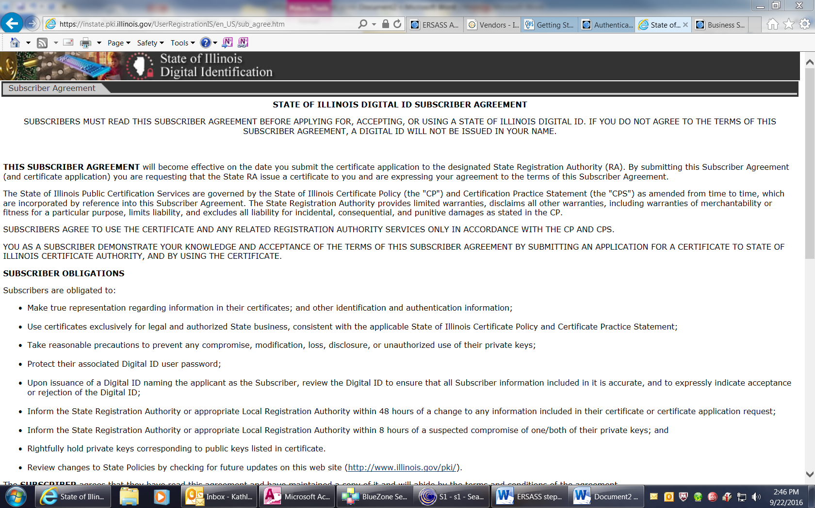
2. Subscriber Agreement—Top of Page

- Read the agreement and then select the appropriate response at the bottom of the page.

3. Subscriber Agreement—Bottom of Page
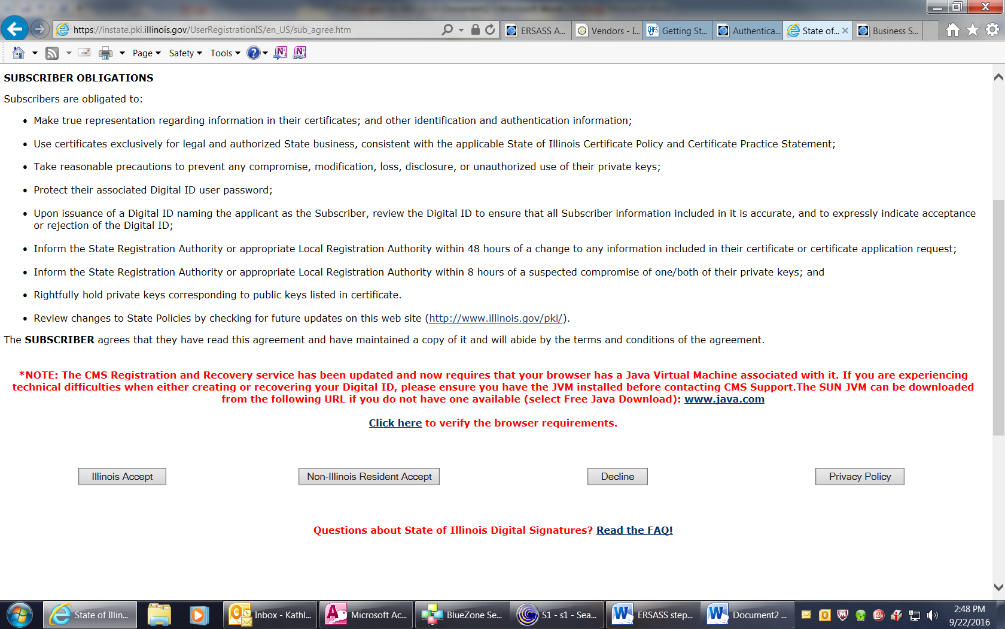
- At the bottom of the Agreement select “Illinois Accept” if you have an Illinois driver’s license and “Non-Illinois Resident Accept” if you do not.
- Illinois residents will complete the page that follows with their Illinois driver’s license. Then they will enter a secret question and answer, followed by a user name and password.
- Non-Illinois residents will follow the instructions on the pages that follow.

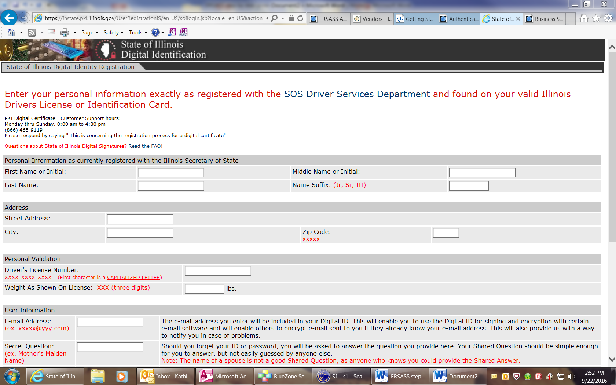
4. Illinois Residents – Enter Personal Information

- Once the Illinois resident’s information is accepted, a “digital certificate” will be granted and will then have access to the MEDI System. This is step one of the registration.
- Step two begins with logging into the MEDI System (next page).

5. MEDI System Login
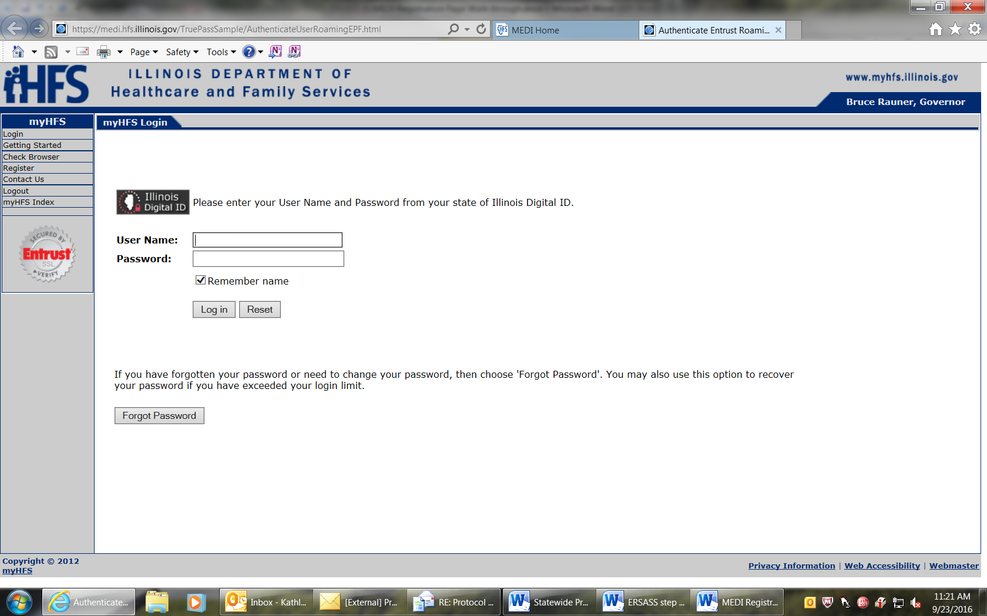
- Once logged in, the provider will select “registration menu” from the column on the left.

6. MEDI Administrator
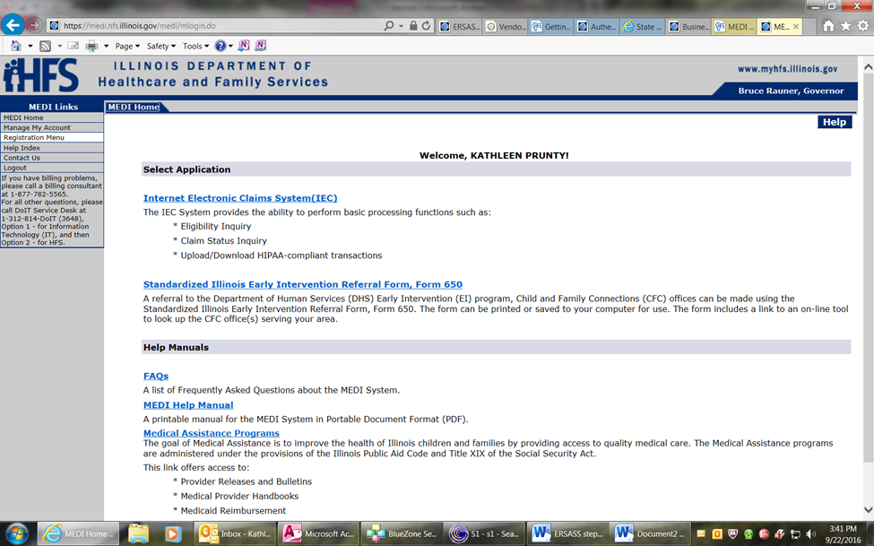

- Select either “Medicaid Provider” to become a MEDI Administrator, or “Employee Registration” to become an employee in the MEDI system.
- Each hospital can have up to 6 MEDI Administrators, and an unlimited number of employees.
- A MEDI Administrator CANNOT SHARE their user name and password under any circumstance.

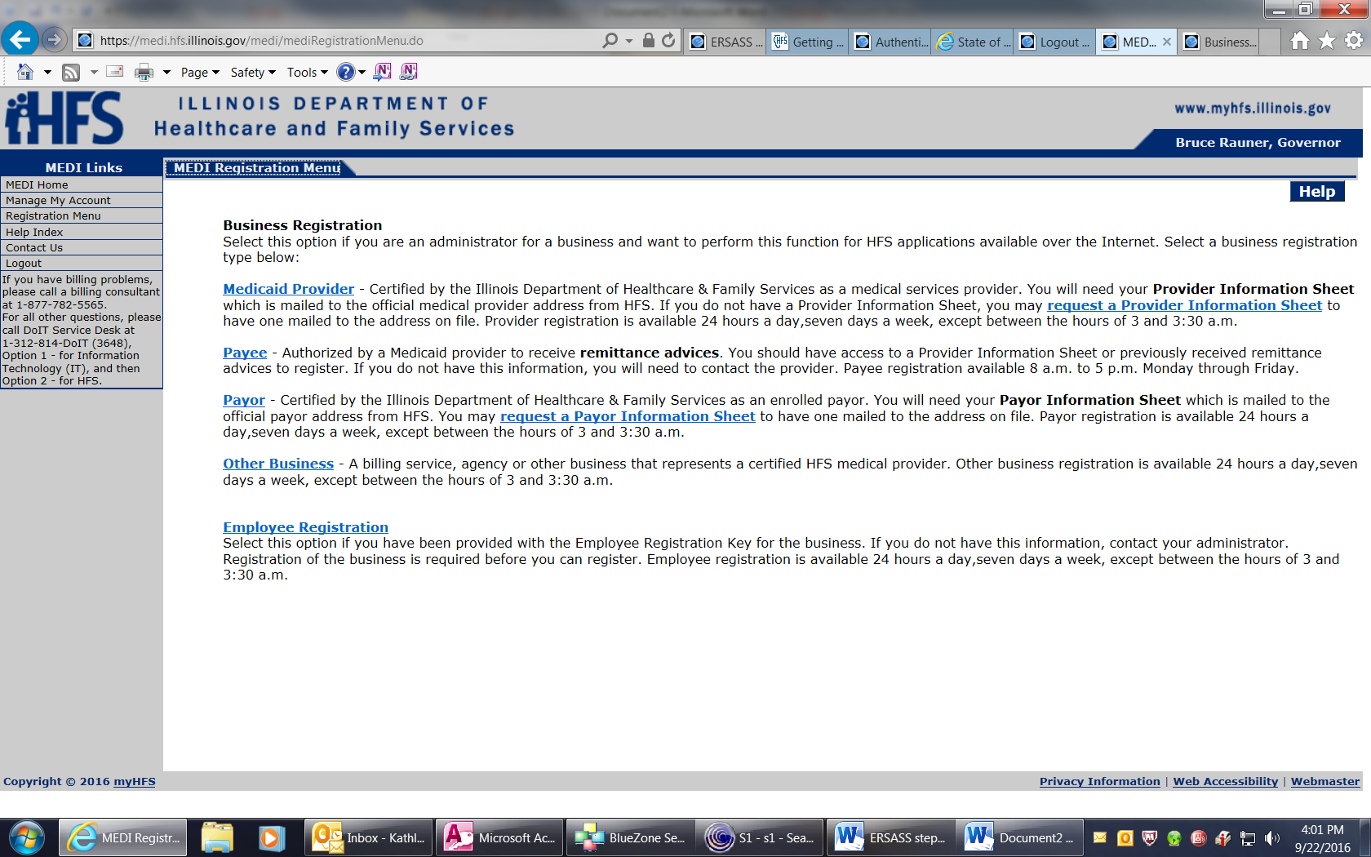
7. Business Registration

- If a person attempting an Administrator registration does not know the required information about their company, they will need to request a ‘Provider Information Sheet’ as suggested on the page above.
- They may want to consult their billing department first though, as they may be able to provide the necessary information.

8. MEDI Administrator Page
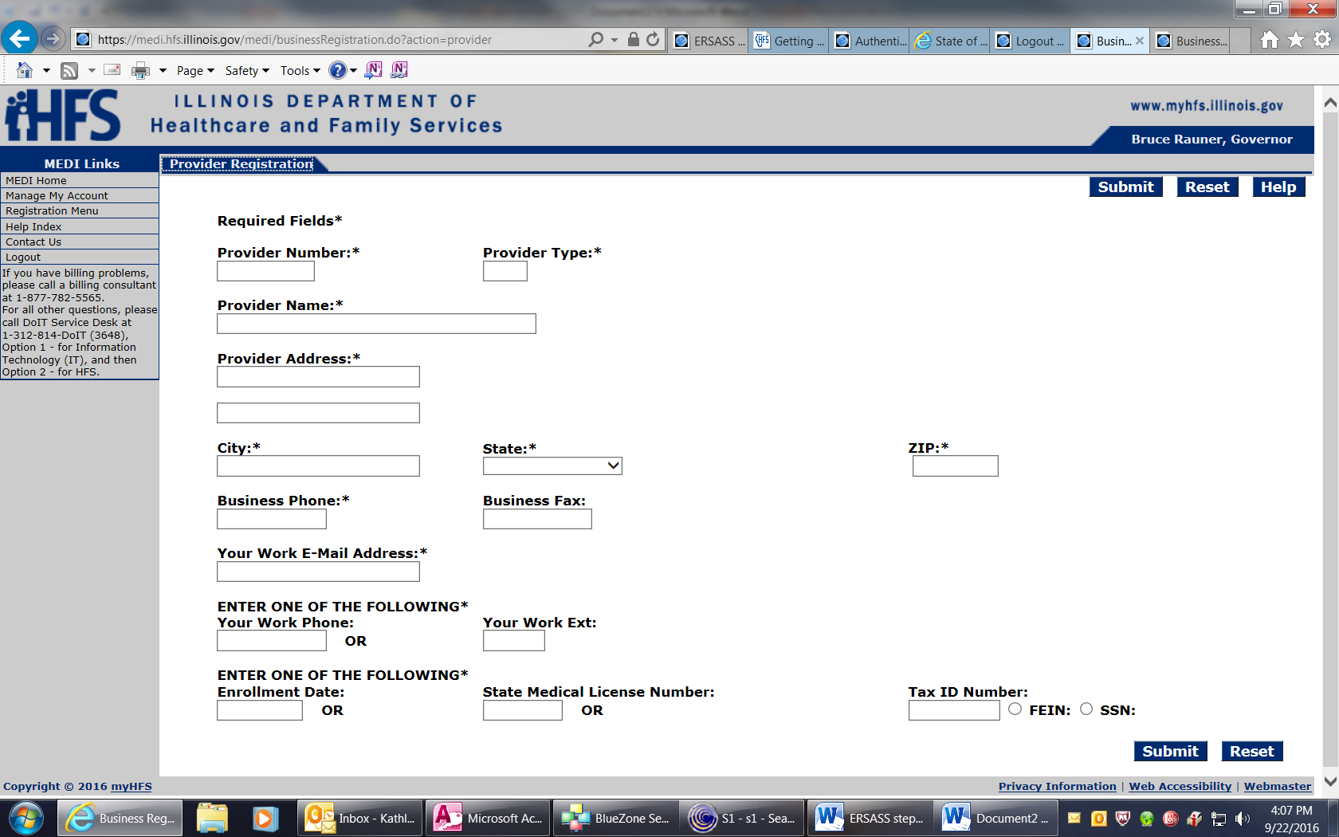

NOTES:
  - Provider Type is always ‘030’
  - Information must match their Medicaid enrolment.
  - No punctuation is allowed in name or address.
  - Phone numbers require dashes
  - At the bottom under “Enter one of the following*”, the provider should enter Tax ID Number and select dot before FEIN. Disregard Enrollment Date and State License Number.

9. Employee Registration Page
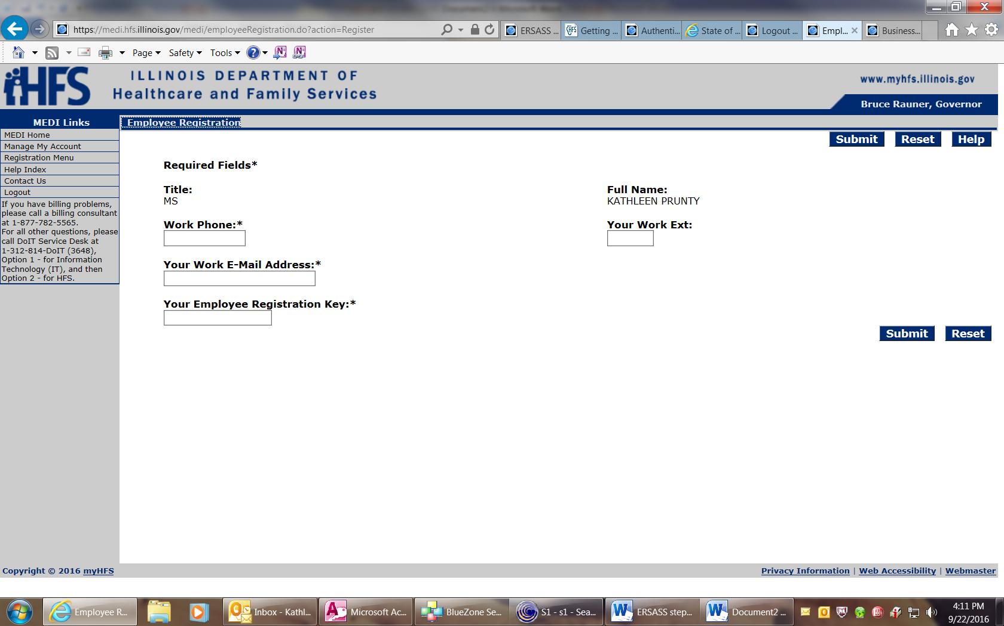
Under “Manage My Account” the administrator will find the ‘Employee Registration Key’ that the employee needs for this registration page.
- Once the employee has completed this page, the MEDI Administrator must log in under the administrator’s user name and password to authorize the employee for the “ERSA” application.
- The Administrator clicks on “Manage My Account” on the left side menu.
- Once they select their business association they can select “Authorize” to be taken to a list of staff registered to use the MEDI System under their provider name and number.
- The new employee will be listed as “Pending.” They can select the employee and then change the employee status to ‘accepted’ and select the applications they are to be approved for. For the purpose of sexual assault, the employee should only be approved for the “ERSA,” the Early Registration of Sexual Assault Survivors application.
- Once this has been done, when the Employee logs into MEDI, they will see the “Early Registration of Sexual Assault Survivors” as their available application. Separate instructions are available for using the ERSA application.

