**Illinois Sexual Assault Survivor Registration System: Registration Instructions**

**1. ERSASS Home Page**

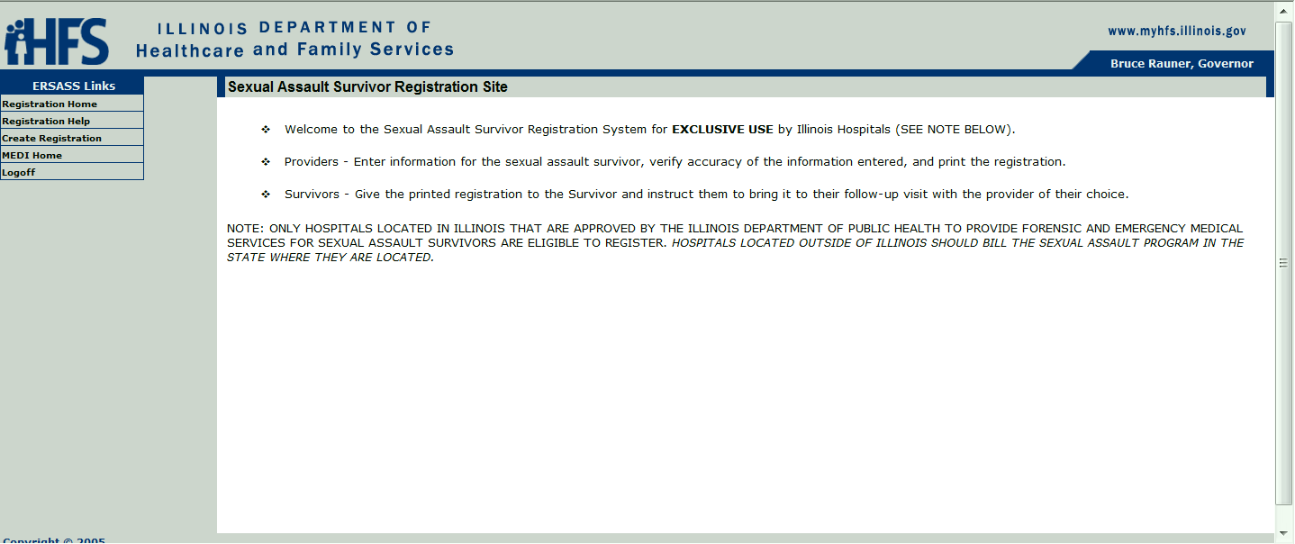

* Select “Create Registration” on left

**2. ERSASS Registration Tab**

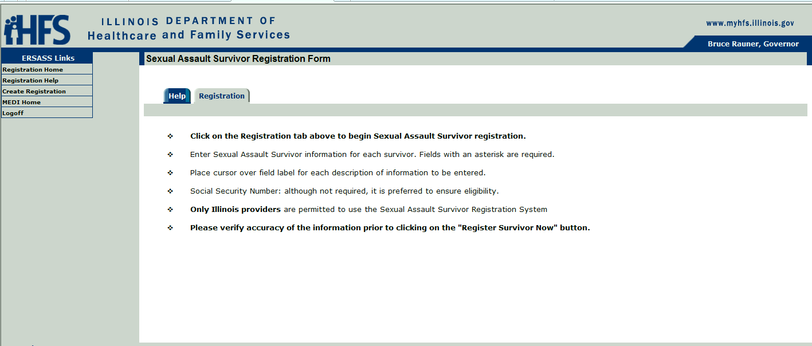

* Select the “Registration” tab in middle screen

**3. ERSASS Registration**

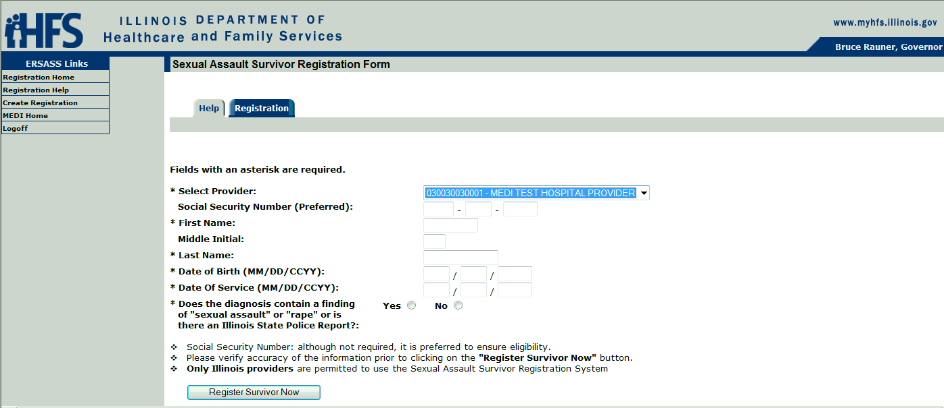

a. Select the hospital you are working under (if registered at more than one)

b. Complete all fields with an asterisk (*) and answer the yes/no question

c. Click “Register Survivor Now” button at bottom

**4. Completed ERSASS Registration**

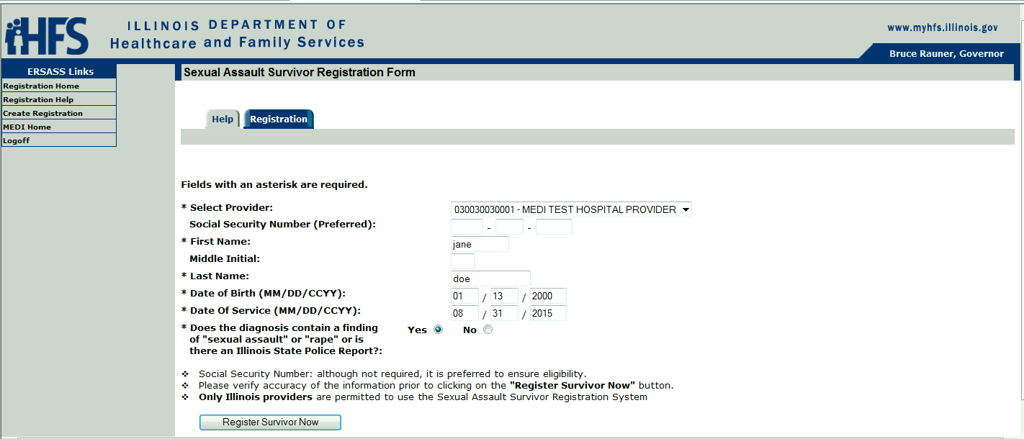

## a. Answer the yes/no question again.

## Please note: The patient must have been seen/examined for sexual abuse and a physician diagnosis indicating that the patient was seen/treated for sexual abuse must be documented. Without the physician diagnosis to confirm, the patient’s visit and related care CANNOT be covered by this program.

## b. Click “Register Survivor Now”

## Registration information will come up.

## c. Click “View Payment Voucher”

## Then print. Three pages will print.

## Please note: It is recommended that you print the voucher twice. Give one copy of pages 1-2 to the patient. Keep the second copy on file at the hospital. *An approved voucher cannot be accessed after the patient registration screen is cleared.*

**5. Authorization for Payment Voucher**