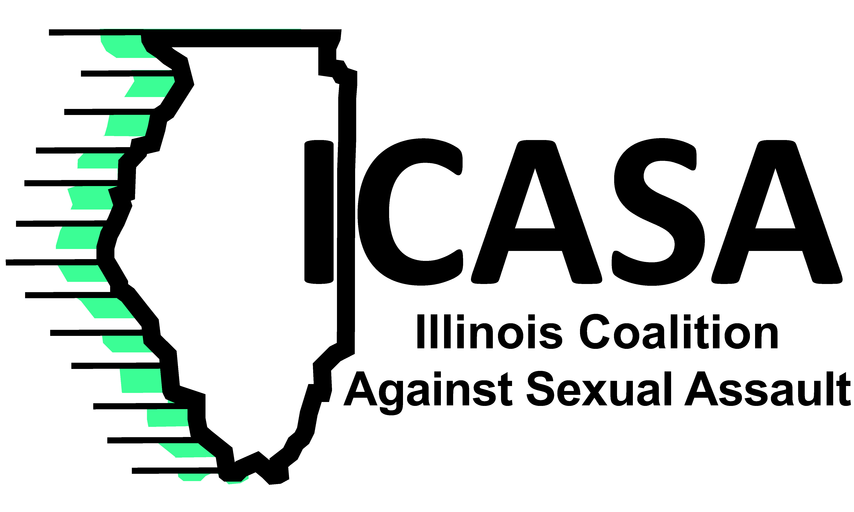
September 19, 2014 Contact: Polly Poskin
217-753-4117 or pposkin@icasa.org
ICASA supports new campaign
It is on all of us.
The Illinois Coalition Against Sexual Assault stands with the White House in the unveiling of the “ItsOnUs” public service campaign to end sexual assault on college campuses. ICASA supports President Obama and Vice President Biden in their efforts to combat the epidemic of sexual violence on college campuses. The ItsOnUs campaign, www.itsonus.org, is a vital step in speaking up about the pervasiveness of sexual violence and urging everyone to get involved in stopping rape and sexual abuse.
“ICASA applauds President Obama’s continued focus on ending sexual assaults on campuses,” ICASA Executive Director Polly Poskin said. “Sexual assault will end when victims are supported and perpetrators are held accountable. We need institutions and individuals, men and women to do the work that supports victims, and eventually, brings an end to sexual violence.”
The “ItsOnUs” campaign follows the “NotAlone” campaign as the President’s administration leads the public discussion on how campuses must improve their response to sexual assault. Rape crisis centers are crucial in this effort as they provide the victim-centered response that best serves the communities. Studies show that 1 in 5 college-age-women are victims of sexual assault. Rape crisis centers are willing to expand their work with campuses to make higher education a safe, violence free environment for all students and personnel.
“Everyone must work together to reduce sexual violence on college campuses. College and universities must do a better job responding to sexual violence and all students on those campuses must become active in addressing the victimization that is prevalent around them,” Poskin said. “This campaign and all of the federal government’s recent efforts are a start to ending sexual violence on college campuses. We must keep urging that effort forward.”

